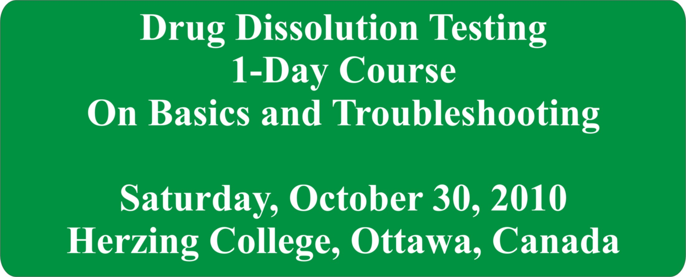

This course is designed to provide: (1) clear understandings of the principles, uses and practices of dissolution testing; (2) suggestions for improving and simplifying the testing by addressing the limitations of current practices; (3) demonstration and availability info for the crescent-shaped spindle.

Course Topics:

- Theory in practical terms: Definitions, relevance and needs.
- Instrumentations: Commonly described and used apparatuses, standardisation or lack of.
- Variability in dissolution results: What it means, sources of variability, impact on product evaluation.
- Evaluating products: Underlying assumptions and limitations.
- Recent developments: Crescent-shaped spindle, principles and logic behind it, some applications.
- Applying modifications for improved output under current requirements.

Course Instructor: Saeed A. Qureshi, Ph.D.

Dr. Qureshi has been involved in all aspects of drug dissolution testing for the past 20+ years and is very well known in the area for his innovative but practical ideas. He has extensively published on the subject and is currently contributing and moderating the www.drug-dissolution-testing.com blog.

For information on future courses, please contact: moderator@drug-dissolution-testing.com

